Coagulopathy of Liver Disease is Not a Contraindication to Neuraxial Anesthesia- A Case Report in A Patient With Acute Fatty Liver of Pregnancy
Jingxia Meng, Roni Mendonca, Michael Girshin, Ejaz Khan
Department of anesthesiology
Metropolitan Hospital, 1901 1st Ave, New York

Abstract

Neuraxial anesthesia techniques, including epidural, spinal, and combined spinal-epidural procedures, are generally contraindicated in patients with coagulopathy due to the increased risk of spinal epidural hematoma. However, for cesarean delivery, neuraxial anesthesia is preferred over general anesthesia (GA) due to its association with reduced maternal morbidity and mortality—primarily by avoiding airway complications and minimizing neonatal drug exposure.
We present a case of a patient with acute fatty liver of pregnancy (AFLP) and coagulopathy at admission who underwent spinal anesthesia without complications. It is likely not just by luck. Upon further literature review, we found that patients with liver disease are not at increased risk of bleeding; no increased risk of spinal hematoma; the decision to perform neuraxial anesthesia should not be based solely on coagulation lab results. A comprehensive patient history obtained from the patient, family, or medical records is often more informative than routine clotting screens.
This case suggests that focusing on correcting coagulopathy based solely on laboratory results before an emergent cesarean section can potentially delay the procedure, leading to worse maternal and neonatal outcomes. Also highlights the need to reassess and update current guidelines by examining the predictive value of coagulation laboratory tests for bleeding risk.

Introduction
Neuraxial anesthesia is a cornerstone of obstetric anesthesia, offering significant benefits over general anesthesia for cesarean deliveries, including reduced maternal morbidity and mortality. However, coagulopathy remains a well-known contraindication due to the risk of spinal epidural hematoma. This cautionary approach has become ingrained in clinical practice, often leading to the automatic exclusion of neuraxial techniques in patients with abnormal coagulation profiles. Yet, emerging evidence challenges the traditional reliance on coagulation tests alone to predict bleeding complications.
In particular, liver disease, including acute fatty liver of pregnancy (AFLP), presents a unique clinical scenario where laboratory evidence of coagulopathy may not accurately reflect bleeding risk. We present a case of successful spinal anesthesia in a patient with AFLP and admission coagulopathy, highlighting the importance of individualized risk assessment. This case underscores the need to reevaluate current guidelines by focusing on clinical context and the predictive limitations of laboratory tests, potentially paving the way for safer and more effective neuraxial anesthesia in patients with liver dysfunction.

Case presentation
A 41-year-old female, G10P3063, at 38 weeks of gestation presented with nausea, vomiting, and heartburn. On admission, her blood pressure was 140/109 mmHg, and her heart rate was 116 bpm. The initial physical examination was unremarkable. However, fetal monitoring revealed recurrent late decelerations with minimal variability, prompting an urgent cesarean delivery. Due to the emergent nature of the case, there was insufficient time to await lab results.
Given the patient’s active vomiting, spinal anesthesia was administered using 1.6 mL of hyperbaric bupivacaine. Shortly after the procedure, icteric sclerae were noted. A stillborn male fetus was delivered. The anesthesia team promptly placed an additional large-bore intravenous (IV) line in anticipation of possible blood transfusion. Estimated blood loss was 1300 mL, and 350 mL of blood was transfused. Emergent lab tests, including liver function tests (LFTs) and coagulation profiles, were obtained, and close neurological monitoring was initiated to assess for potential spinal or epidural hematoma.
Laboratory results (table 1) revealed transaminitis, prolonged PT/INR and aPTT, acute kidney injury, and hypoglycemia, confirming the diagnosis of acute fatty liver of pregnancy (AFLP) based on the Swansea criteria. Liver ultrasound showed echogenic liver representing fatty liver infiltration versus diffuse parenchymal disease. No spinal or epidural hematoma developed. On postoperative day 4, the patient’s hemoglobin dropped to 6.4 g/dL, platelets decreased to 44 × 10⁹/L, and a hematoma developed within the abdominal rectus muscles. Dynamic lab test results are shown in Table 1. Over the following days, she developed pancreatitis, disseminated intravascular coagulation (DIC), and renal failure. Supportive care was provided, and she was discharged on postoperative day 13 in stable condition.

Table 1: lab test results.
 | Baseline | admission | Day 2-6  Lowest/highest | Day 7 | Day 10 | Normal reference value
AST | 21 (7 months ago) | 532 | 532 | 70 | 49 | 0 - 32 U/L
ALT | 29 | 611 | 611 | 29 | 31 | 0 - 31 U/L
ALK PHOS | 87 | 545 | 545 | 94 | 114 | 35 - 104 U/L
Total/direct bilirubin | 0.4/NA | 6.0/4.0 | 10.2/6.6 | 7.9/4.6 | 5.9/2.8 | Total Bilirubin  0.0 - 1.2 mg/dL  Direct Bilirubin  0.0 - 0.3 mg/dL
Total protein/albumin | 7.1/4.4 | 7.0/3.8 | 5.1/2.0 | 5.3/3.5 | 7.1/5.3 | Total Protein  6.6 - 8.7 g/dL  Albumin  3.5 - 5.2 mg/dL
Creatinine | 0.67 | 3.7 | 6.8 | 2.2 | 1.1 | 0.7 - 0.9 mg/dL
Hemoglobin | 14.1 | 17.9 | 6.4 | 9.0 | 11.1 | 12.0 - 16.0 g/dL
platelet | 313 | 188 | 44 | 44 | 146 | 150 - 450 x10(3)/mcL
aPTT | N/A | 53.6 | 53.6 | 30.7 | 26.7 | 25.1-36.5 seconds
PT/INR | N/A | 22.6/2.1 | 22.6/2.1 | 14.1/1.2 | 12/1 | PT 9.4-12.5 seconds  INR 0.9-1.1
WBC | 9.28 | 19.7 | 30.7 | 10.8 | 12 | 4.30 - 11.00 x10(3)/mcL
Glucose | 90 | 50 | 50 | 100 | 158 | 74 - 109 mg/dL
Fibrinogen | N/A | 125 | 75 | 194 | 195 | 200 - 393 mg/dL
Haptoglobin | <20 | <20 | <20 | <20 | <20 | 34-200mg/dL
LDH | N/A | 595 | 814 | 814 | 659 | 135-214 U/L
Ammonia | N/A | 75 | 90 | 35 | 27 | 16-33 mmol/L
Table 1: laboratory test results (Baseline labs were done 7 months ago)

Figure 1 liver ultrasound picture
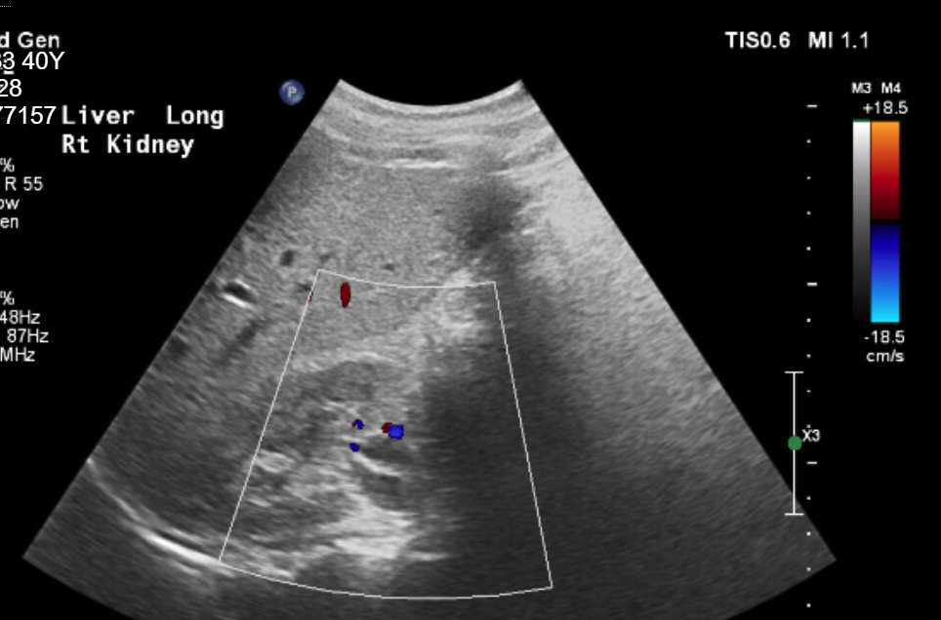
Liver ultrasound: echogenic liver likely representing fatty infiltration versus diffuse parenchymal disease

The Swansea Criteria are used to bring uniformity to the diagnosis of AFLP. They are defined by 6 or more of the following: vomiting, abdominal pain, polydipsia/polyuria, encephalopathy, aspartate transaminase or alanine transaminase > 42 U/L, bilirubin > 0.8 mg/dL, glucose < 72 mg/dL, white blood cell count> 11 × 106/L, uric acid > 5.7 mg/dL, ammonia > 42 IU/L, creatinine > 1.7 mg/dL, prothrombin > 14 sec or partial thromboplastin time > 34 sec, ascites or bright liver on ultrasound, or microvesicular steatosis on biopsy. The criteria have an estimated sensitivity of 100% and a specificity of 57%, with a positive predictive value of 85% and a negative predictive value of 100%

Teaching Points:
- Balanced Hemostasis in Liver Disease: The liver produces both coagulation factors and inhibitors, resulting in a rebalanced hemostatic state in patients with liver disease. These patients are not necessarily at increased risk of bleeding, and bleeding risk is generally low and manageable. Prophylactic administration of fresh frozen plasma (FFP) solely to correct elevated prothrombin time is not recommended.
- Limitations of Coagulation Lab Tests: The decision to perform neuraxial anesthesia should not be based solely on coagulation lab results. Standard coagulation tests such as aPTT and PT/INR were not designed to assess bleeding risk and have limited predictive value. A Danish nationwide population-based cohort study demonstrated a low absolute risk of spinal hematoma within 30 days of lumbar puncture, with no significant difference between patients with and without coagulopathy.
- Value of Comprehensive Clinical Assessment: A detailed patient history obtained from the patient, family, or medical records is often more informative than routine clotting screens when assessing bleeding risk. Platelet count may be a more reliable predictor of bleeding risk than traditional coagulation profiles.

